6115-MAHENDRA INSTITUTE OF ENGINEERING AND TECHNOLOGY
ENVIRONMENTAL MONITORING
Team Members:
✯ M.SARATHI
✯ M.PUGAZHENTHI
✯ S.OMKAR SATYAVAN SURYAVANSHI
✯ S.SANJAI
✯ E.SAKTHIVEL
✯ M.RAGHUVARAN
Mentor Name:
✯ M.SANTHANARAJ

INSTALLATION
Setting up an environmental monitoring system involves several steps, including choosing the right sensors, hardware, software, and deployment strategy. Here's a general guide on how to install an environmental monitoring system
Define Your Monitoring Objectives: Determine the specific environmental parameters you want to monitor, such as temperature, humidity, air quality, water quality, soil conditions, etc.
Select Sensors and Hardware: Choose appropriate sensors and instruments based on your monitoring objectives.
Consider factors like sensor accuracy, calibration, measurement range, and connectivity options (e.g., wired or wireless).Decide on data loggers or microcontrollers to collect and process data.
Data Acquisition System: Set up a data acquisition system to collect data from the sensors.This could be a microcontroller (e.g., Arduino, Raspberry Pi), data logger, or dedicated data acquisition hardware.
Connect Sensors: Physically install the sensors at the chosen monitoring locations.Ensure sensors are correctly calibrated and connected to the data acquisition system.
Data Storage and Analysis: Set up a data storage system, which could be a local database or cloud-based service.Implement data analysis tools to process and interpret the data.
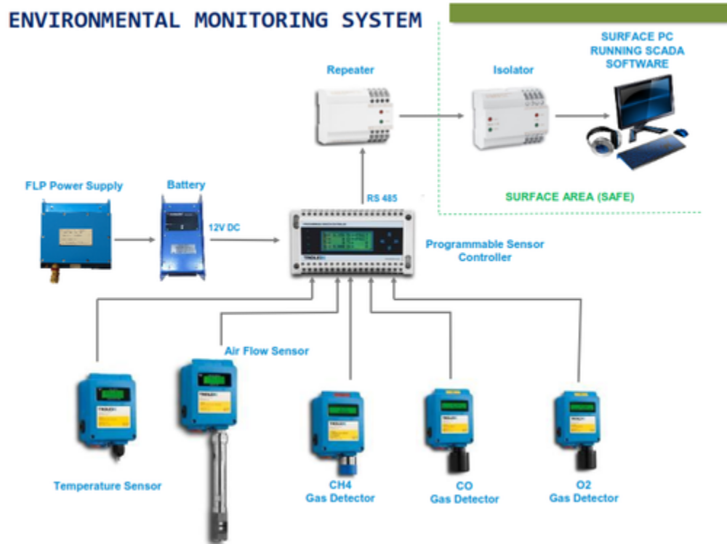

PLANNING

Identify Environmental Parameters: Determine which specific environmental parameters you need to monitor. This could include temperature, humidity, air quality, water quality, soil conditions, biodiversity, pollution levels, and more.
Select Monitoring Locations: Identify the geographic locations or areas where monitoring is needed. Consider factors like environmental sensitivity, proximity to pollution sources, and accessibility.
Budget and Resources:Determine the budget and resources required for your monitoring program. This includes costs for sensors, data acquisition systems, personnel, data analysis tools, and ongoing maintenance.
Sensors and Equipment Selection:Choose appropriate sensors and monitoring equipment based on your objectives and the environmental parameters you're monitoring. Consider factors like sensor accuracy, calibration, measurement range, and connectivity options.
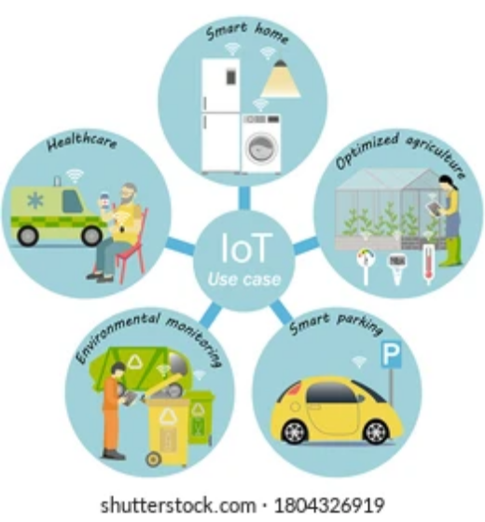

CONTROLLING

environmental monitoring controlling involves managing and overseeing the environmental monitoring program to ensure it operates effectively and efficiently. This typically includes tasks such as setting up sensors, configuring data collection and analysis processes, ensuring data accuracy, and responding to various environmental conditions. Below are some key steps for controlling an environmental monitoring system
Sensor Configuration:Install and configure the sensors you need to monitor the specific environmental parameters relevant to your project, such as temperature, humidity, air quality, or water quality. Ensure they are correctly connected and calibrated.
Data Collection: Set up data collection mechanisms to gather data from your sensors. This might involve using sensor-specific libraries or interfaces.
Data Quality Assurance:Regularly verify the quality and accuracy of collected data. This may involve calibrating sensors, checking for anomalies, and addressing issues promptly.
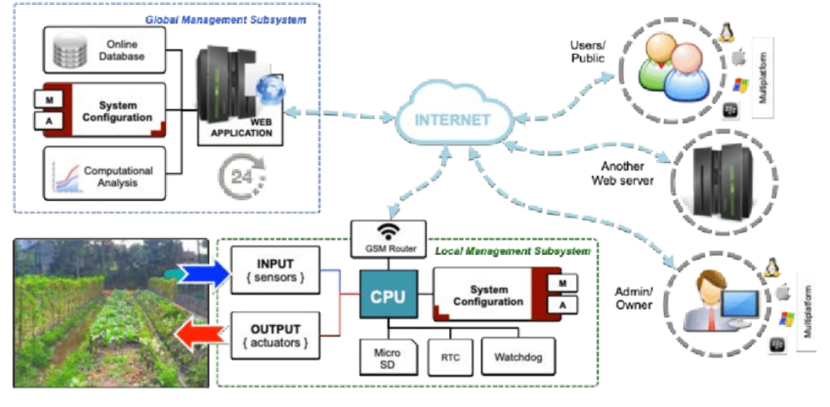

EXECUTION

program code:
import time
import random
import csv
# Function to simulate a temperature sensor reading
def read_temperature():
# Simulate a temperature reading between 0 and 40 degrees Celsius
return round(random.uniform(0, 40), 2)
# Function to record environmental data to a CSV file
def log_environment_data(data, filename):
with open(filename, 'a', newline='') as file:
writer = csv.writer(file)
writer.writerow(data)
# Main program loop
if __name__ == "__main__":
data_filename = "environmental_data.csv"
try:
while True:
# Read temperature data
temperature = read_temperature()
# Get current timestamp
timestamp = time.strftime("%Y-%m-%d %H:%M:%S")
# Store the data in a list
data = [timestamp, temperature]
# Log the data to the CSV file
log_environment_data(data, data_filename)
print(f"Timestamp: {timestamp}, Temperature: {temperature}°C"
# Wait for a specified interval (e.g., 5 minutes)
time.sleep(300)
except KeyboardInterrupt:
print("Monitoring program stopped.")

THANK YOU!!!

